Appendix C: IEEE 830 Template
Software Requirements Specification
for
CLI python backend

Version 1
Prepared by Maciej Giermala
TUL
11.03

Table of Contents
«Table of Contents»
Revision History
Name | Date | Reason for Changes | Version
Maciej | 11.03 | Initial version | 1
Maciej | 18.03 | Added the UCD and System Features | 2

1. Introduction
1.1. Purpose
This document specifies the software requirements for the Logic Circuit Simulator v1.0. The product is a command-line interface (CLI) application that allows users to build, evaluate, and persist digital logic circuits. The scope includes defining logical inputs, connecting standard logic gates (AND, OR, NOT, NAND, NOR, XOR), generating truth tables, and saving/loading circuit states to JSON files.
1.2. Document Conventions
This document follows the IEEE 830 Software Requirements Specification standard. Requirements are written as atomic, verifiable statements. Functional requirements use the prefix FR-x, and non-functional requirements use NFR-x. The keyword "shall" indicates mandatory system behavior.
1.3. Intended Audience and Reading Suggestions
The intended audience includes developers (engaged in pair-programming/ping-pong development), software testers, and students learning digital logic. It is recommended to read the Overall Description first to understand the CLI flow, followed by System Features for exact command specifications.
1.4. Product Scope
The Logic Circuit Simulator provides a lightweight, fast backend for defining Boolean logic systems. It aims to eliminate manual truth table calculations by automatically evaluating complex, multi-gate circuits and detecting logical errors (e.g., cyclic dependencies).
1.5. References
«List any other documents or Web addresses to which this document refers or was based on. These may include user interface style guides, contracts, standards, system requirements specifications, use case documents, or a vision and scope document. Provide enough information so that the reader could access a copy of each reference, including title, author, version number, date, and source or location. Include the assignment document in the references.»
2. Overall Description
2.1. Product Perspective
The system is a standalone Python CLI application. It does not require a graphical user interface and operates entirely through terminal commands, making it ideal as a backend logic engine or an educational tool.
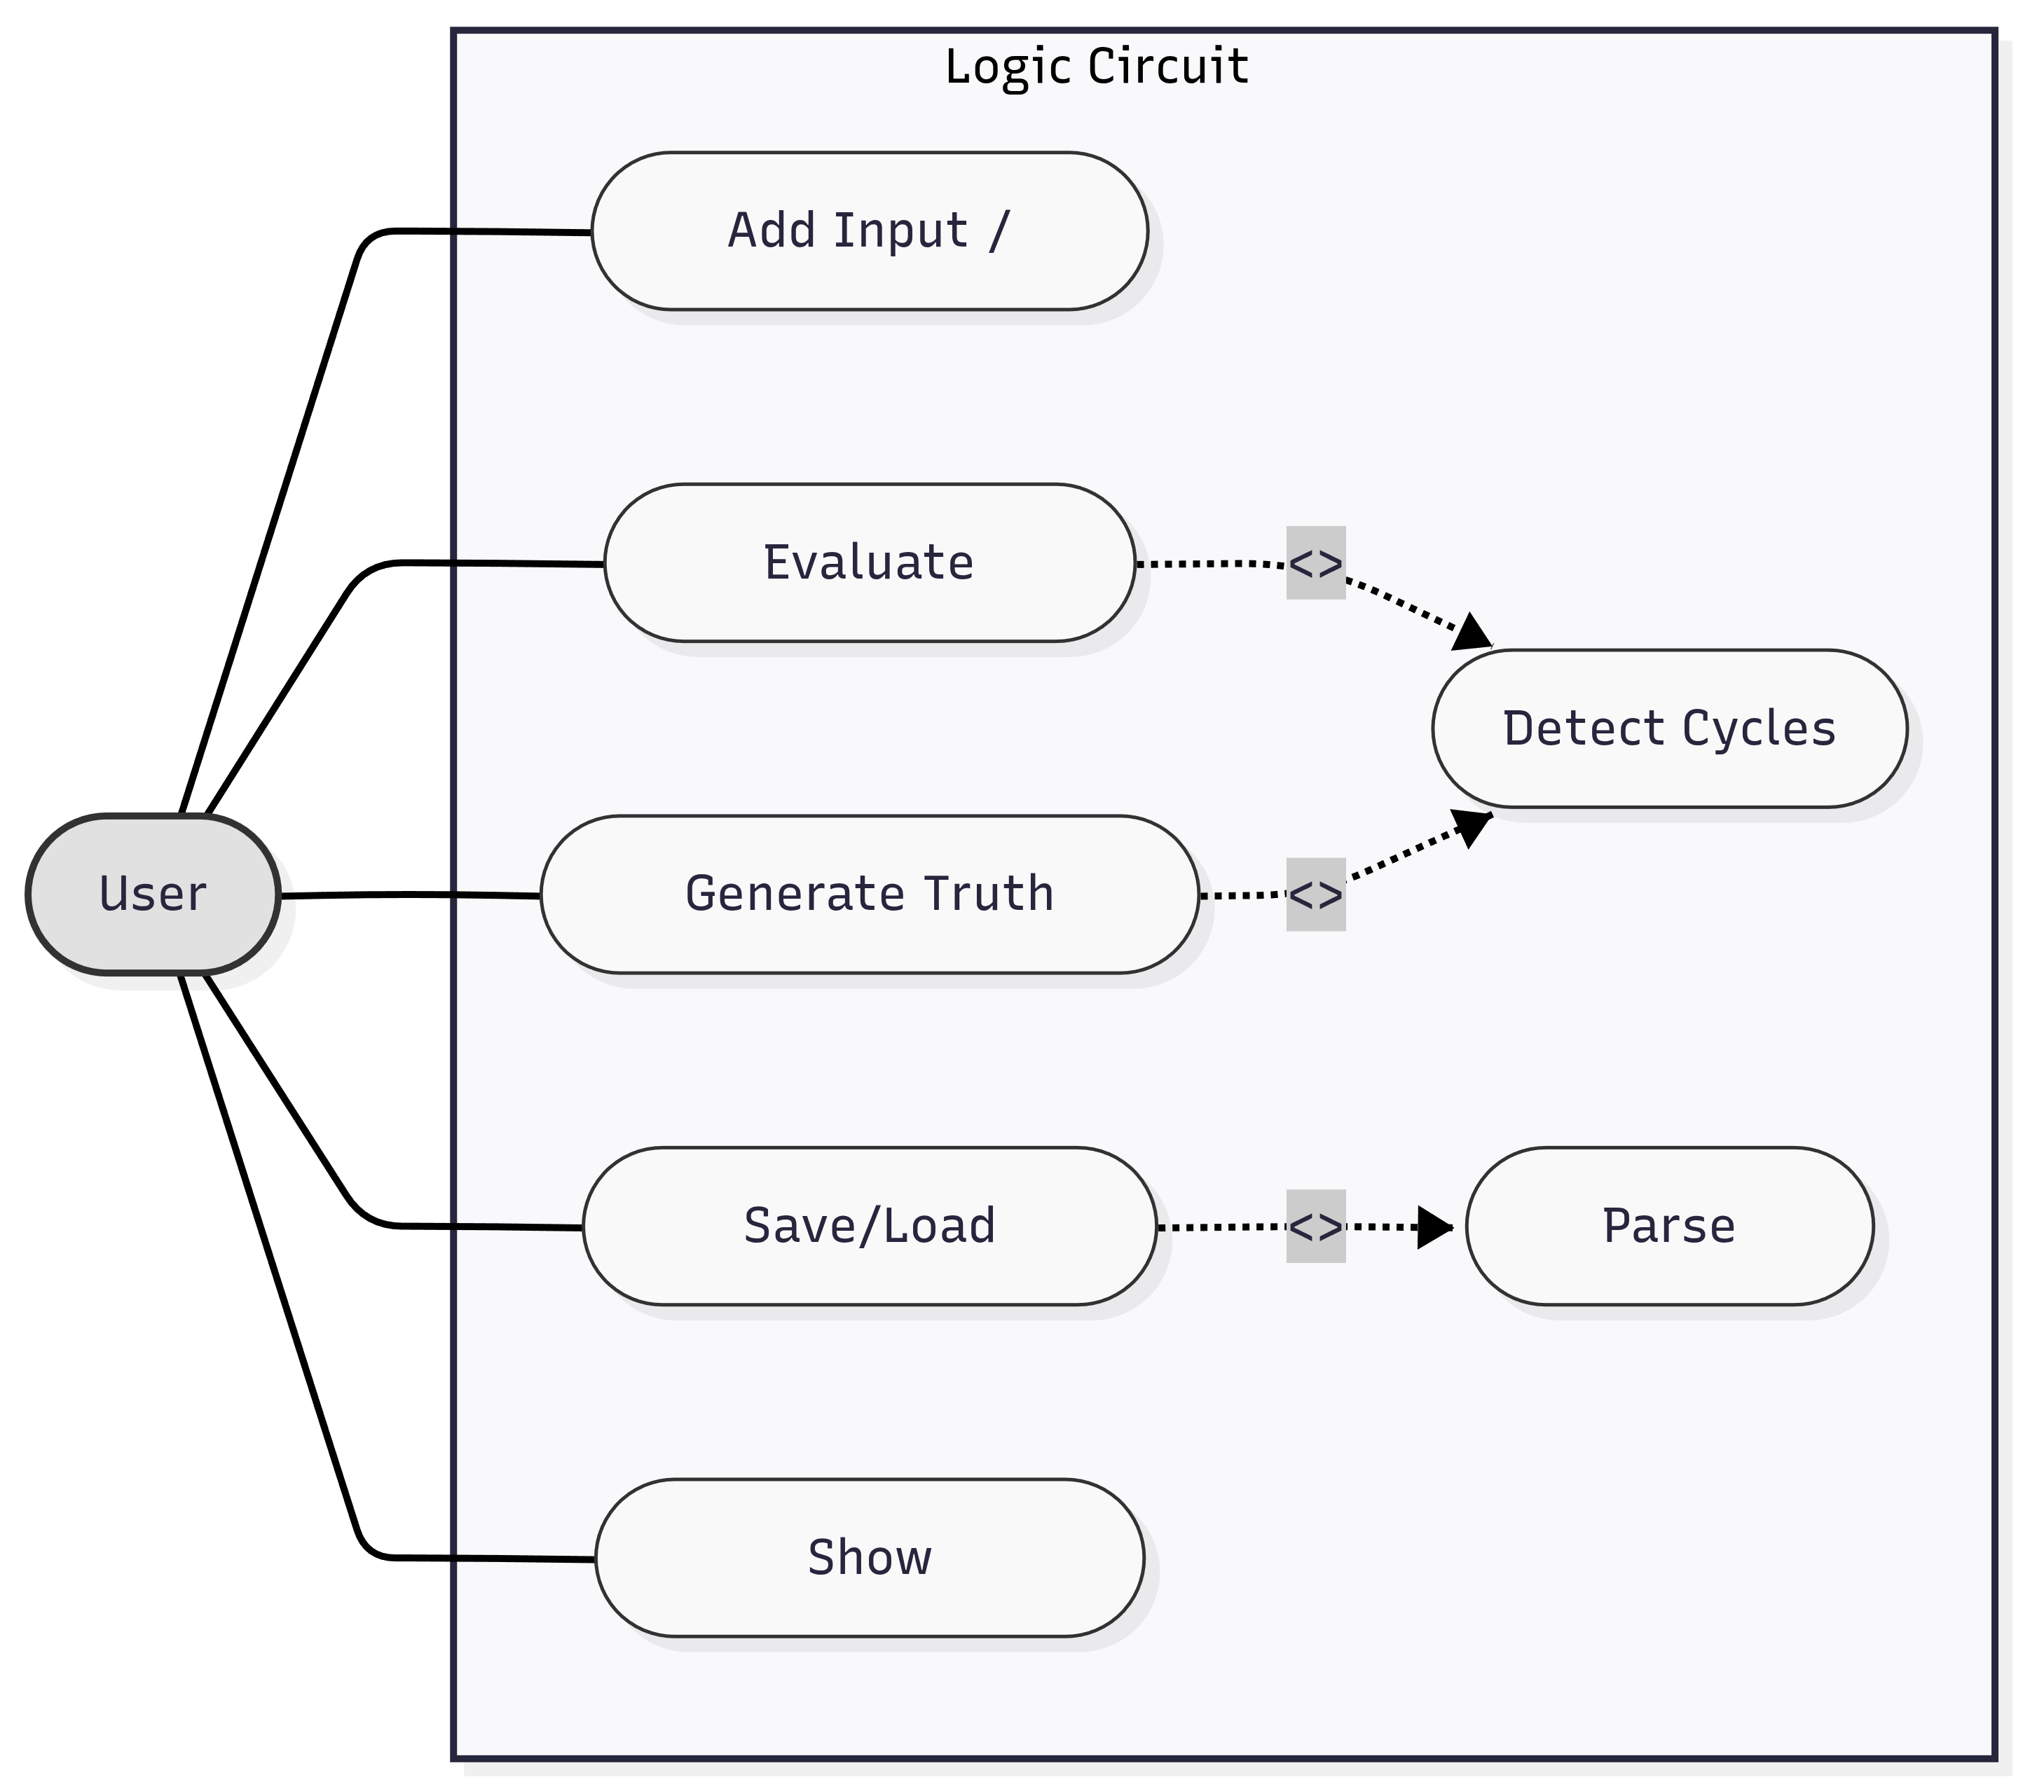

2.2. Product Features
- Circuit Construction: Users can dynamically add named inputs and logic gates (AND, OR, NOT, NAND, NOR, XOR).
- State Evaluation: The system computes the output of the circuit based on provided input states using topological sorting.
- Truth Table Generation: The application automatically generates full truth tables for all possible input combinations.
- State Persistence: Circuits can be serialized to and deserialized from JSON files (Save/Load).
- Safety Checks: Automatic detection of cyclic dependencies to prevent infinite evaluation loops.

2.3. User Classes and Characteristics
- Students/Engineers: Primary users who interact with the CLI to test logical expressions. They require clear error messages and intuitive command syntax.
- Developers: Users extending the code. Because the project is built using Test-Driven Development (Ping-Pong method), the codebase is heavily modularized (separated into main.py and circuit.py) to facilitate easy testing.

2.4. Operating Environment
The software operates on any operating system (Windows, macOS, Linux) that supports Python 3. No external third-party libraries are required, as it relies on standard Python modules (e.g., json, enum, itertools).
2.5. Design and Implementation Constraints
The system is constrained to a text-based interface. The evaluation algorithm must prevent infinite loops by detecting cycles before calculating outputs. Furthermore, the development process follows the strict Ping-Pong TDD methodology, meaning all features must be verifiable via automated tests before implementation.
2.6. User Documentation
«List the user documentation components (such as user manuals, on-line help, and tutorials) that will be delivered along with the software. Identify any known user documentation delivery formats or standards.»
2.7. Assumptions and Dependencies
«List any assumed factors (as opposed to known facts) that could affect the requirements stated in the specification. These could include third-party or commercial components that you plan to use, issues around the development or operating environment, or constraints. The project could be affected if these assumptions are incorrect, are not shared, or change. Also identify any dependencies the project has on external factors, such as software components that you intend to reuse from another project, unless they are already documented elsewhere (for example, in the vision and scope document or the project plan).»
3. System Features

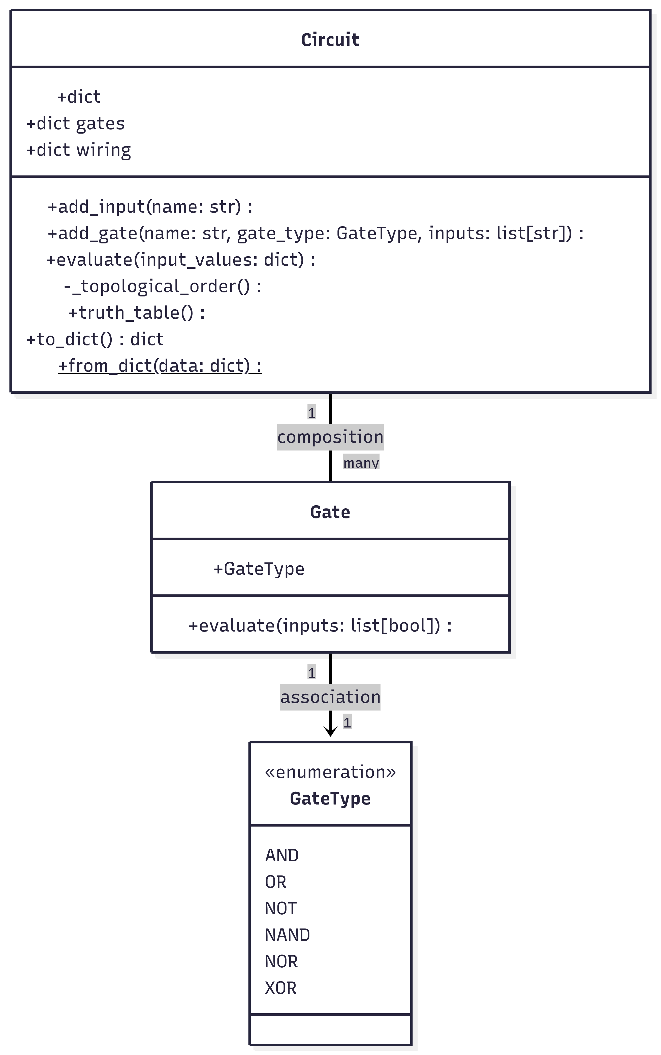

UML Class Diagram. It illustrates the core architecture of the Logic Circuit Simulator. The diagram highlights the composition relationship where the Circuit class manages multiple Gate instances, and the association between each Gate and its respective GateType enumeration. It also details the main attributes and methods responsible for circuit evaluation and persistence.
3.1. Circuit Construction
Allows users to define logic gates and inputs dynamically.
3.2. Circuit Evaluation & Truth Tables
Calculates outputs and generates full truth tables while detecting cyclic dependencies.
3.3. State Persistence
Allows saving and loading the circuit configuration via JSON files.4. External Interface Requirements
4.1. User Interfaces Overview
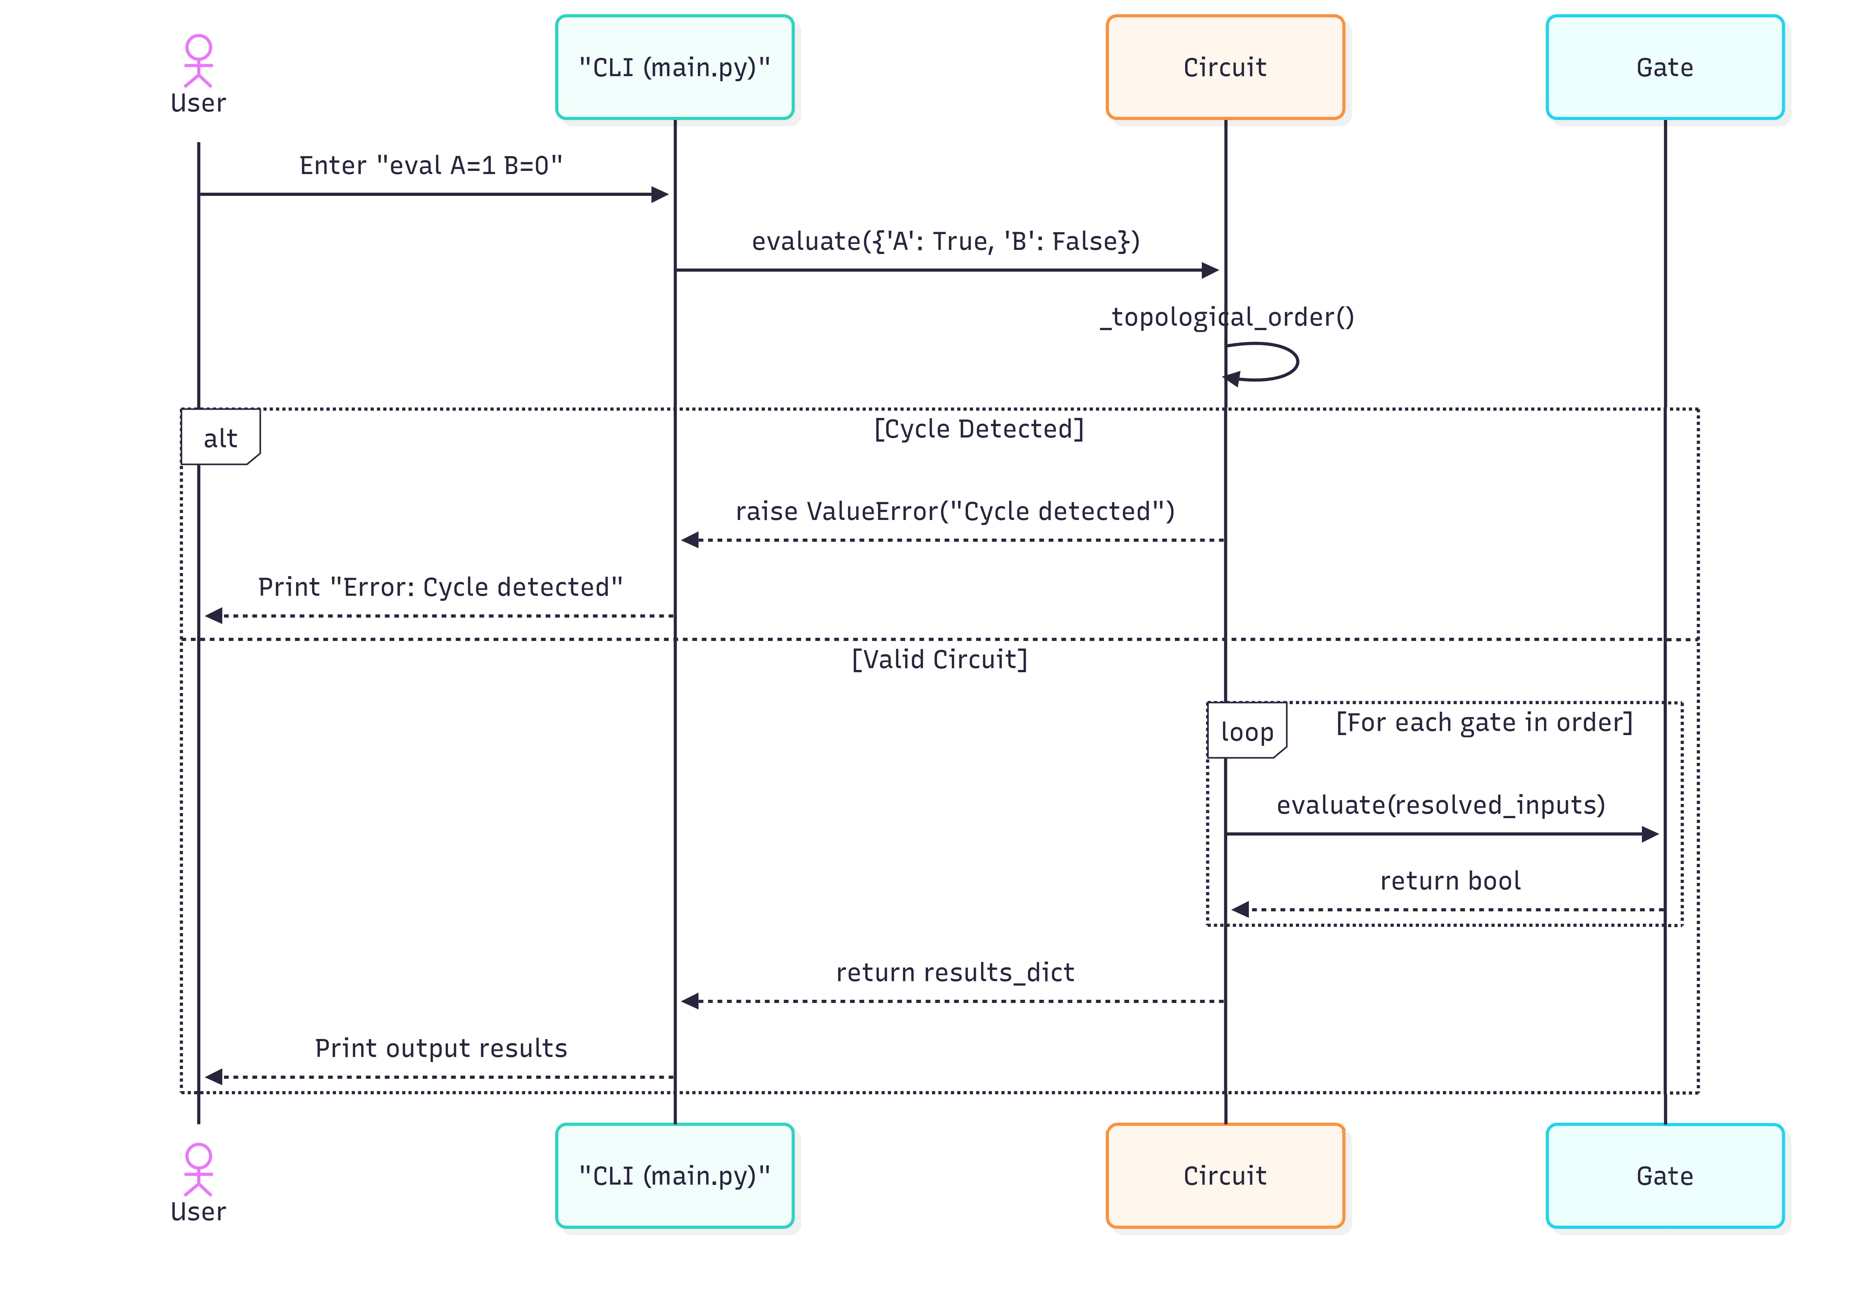
4.2. Hardware Interfaces
The system does not require any specialized hardware interfaces. It operates on standard computing devices (desktop computers, laptops) equipped with standard input/output peripherals (keyboard for typing commands and a monitor for viewing terminal output).
4.3. Software Interfaces
The application is a standalone Python script and requires the Python 3.x runtime environment to execute. It interacts with the host operating system's file system to perform state persistence. Specifically:
- File I/O: The system reads from and writes to .json files on the local disk using Python's standard json library when the load and save commands are executed.
- Data Format: The shared data format for persistence is strictly JSON, containing serialized lists of inputs and dictionaries of gate definitions and wiring connections.

5. System Features/Modules
5.1. Circuit Construction
5.1.1 Description and Priority
Adding inputs and standard logic gates to build a circuit. Priority: High.
5.1.2 Stimulus/Response Sequences
- User enters input A -> System registers a new input node 'A'.
- User enters gate g1 AND A B -> System registers an AND gate named 'g1' connected to inputs 'A' and 'B'.
5.1.3 Functional Requirements
- FR-1.1: The system shall allow users to add boolean inputs by specifying a unique name.
- FR-1.2: The system shall allow users to add logic gates of types: AND, OR, NOT, NAND, NOR, XOR.
- FR-1.3: The system shall map gate inputs to previously defined input nodes or other gate outputs.
5.2. Circuit Evaluation & Truth Tables
5.2.1 Description and Priority
Evaluating the logic states and preventing infinite loops. Priority: High.
5.2.2 Stimulus/Response Sequences
- User enters eval A=1 B=0 -> System evaluates the logic path and prints the result for all gates.
- User enters table -> System generates a truth table for all possible input combinations.
5.2.3 Functional Requirements
- FR-2.1: The system shall dynamically compute the boolean output of all gates based on provided input values.
- FR-2.2: The system shall generate a topological execution order to ensure gates are evaluated only after their dependencies are resolved.
- FR-2.3: The system shall detect cyclic dependencies (e.g., gate A depends on gate B, which depends on gate A) and throw a ValueError before evaluation.
- FR-2.4: The system shall generate a full truth table encompassing 2^n combinations, where n is the number of inputs.
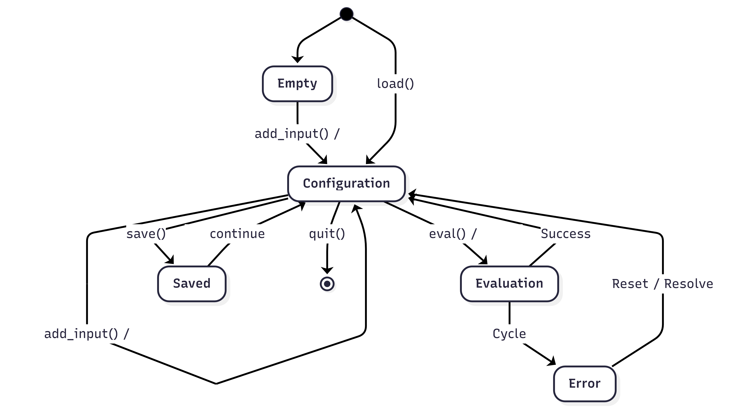
5.3. State Persistence
5.3.1 Description and Priority
Saving and loading circuit state using JSON. Priority: Medium.
5.3.2 Stimulus/Response Sequences
- User enters save my_circuit.json -> System serializes the current circuit to the file.
- User enters load my_circuit.json -> System reconstructs the circuit from the file.
5.3.3 Functional Requirements
- FR-3.1: The system shall serialize the current inputs, gate types, and wiring connections to a JSON format.
- FR-3.2: The system shall clear the current state and instantiate a new circuit model upon loading a valid JSON file.

6. Nonfunctional Requirements
6.1. Performance
- NFR-1.1: The system shall evaluate a circuit with up to 20 inputs within 1 second.
- NFR-1.2: The cycle detection algorithm (topological sort) shall execute in O(V + E) time complexity, where V is the number of gates/inputs and E is the number of wire connections.
6.2. Usability
- NFR-2.1: The system shall provide a text-based Command Line Interface (CLI) that requires no graphical environment to run.
6.3 Reliability
- NFR-3.1: The system shall gracefully handle syntax errors or invalid commands by providing a descriptive error message without crashing.

